**Understanding simple plots…**

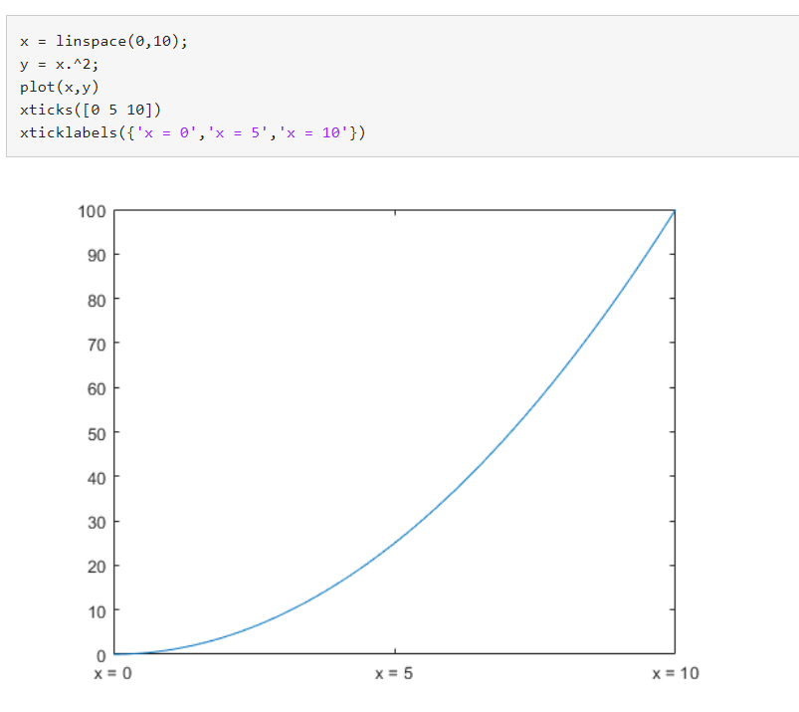

SYMBOLIC FUNCTIONS

syms s(t) f(x,y)

Both s and f are abstract symbolic functions. They do not have symbolic expressions assigned to them, so the bodies of these functions are s(t) and f(x,y), respectively.

Specify the following formula for f.

f(x,y) = x + 2\*y

s(t) = t\*2

Output :

f(x, y) = *x*+2 *y*

*s(t) = 5y*

Evaluating the symbolic functions:

Compute the function value at the point x = 1 and y = 2.

f(1,2)

ans = 5

s(1)

ans =5

ORDINARY DIFFERNTIAL EQUATION

What is the order of the differential Equation?

The order of the highest order derivative present in the differential equation is called the order of the equation. If the order of the differential equation is 1, then it is called the first order. If the order of the equation is 2, then it is called a second-order, and so on.

What is the use of a differential equation?

The main purpose of the differential equation is to compute the function over its entire domain. It is used to describe the exponential growth or decay over time. It has the ability to predict the world around us. It is widely used in various fields such as Physics, Chemistry, Biology, Economics and so on.

## Applications

Differential equations have several applications in different fields such as applied mathematics, science, and engineering. Apart from the technical applications, they are also used in solving many real life problems. Let us see some [differential equation applications](https://byjus.com/maths/differential-equations-applications/) in real-time.

1) Differential equations describe various exponential growths and decays.

2) They are also used to describe the change in return on investment over time.

3) They are used in the field of medical science for modelling cancer growth or the spread of disease in the body.

4) Movement of electricity can also be described with the help of it.

5) They help economists in finding optimum investment strategies.

6) The motion of waves or a pendulum can also be described using these equations.

The various other applications in engineering are: ­ heat conduction analysis, in physics it can be used to understand the motion of waves. The ordinary differential equation can be utilized as an application in the engineering field for finding the relationship between various parts of the bridge.

Now, go through the **differential equations examples** in real-life applications .

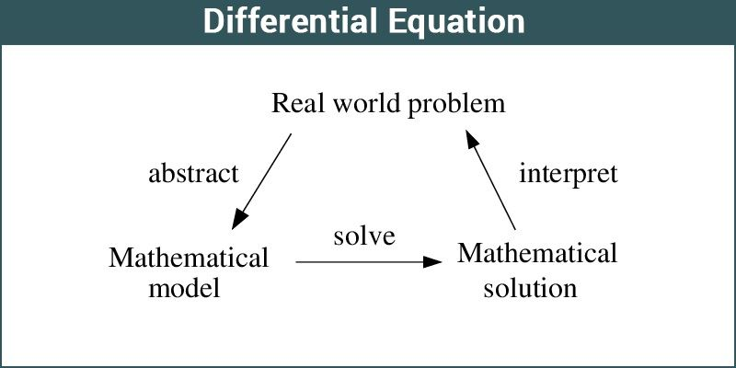

1. An ordinary differential equation ­contains one independent variable and its derivatives. It is frequently called ODE. The general definition of the ordinary differential equation is of the form:­ Given an F, a function os x and y and derivative of y, we have

F(x, y, y’ …..y^(n­1)) = y (n) is an explicit ordinary differential equation of order n.

2. Partial differential equation ­that contains one or more independent variables.

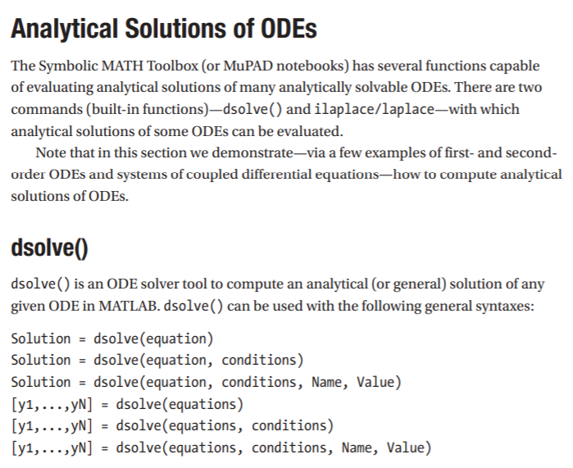

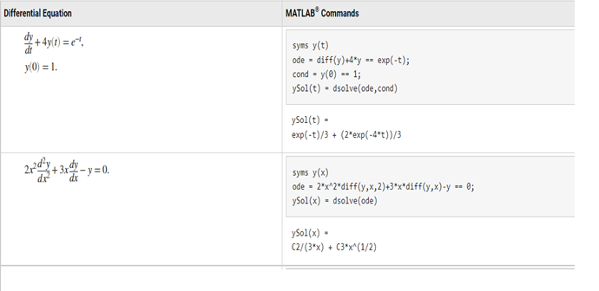

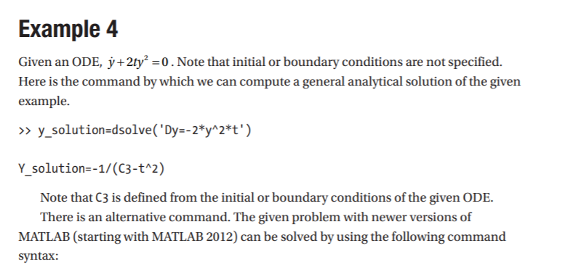

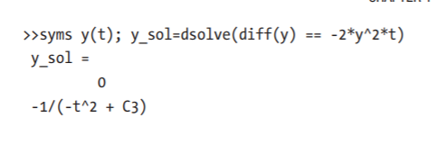

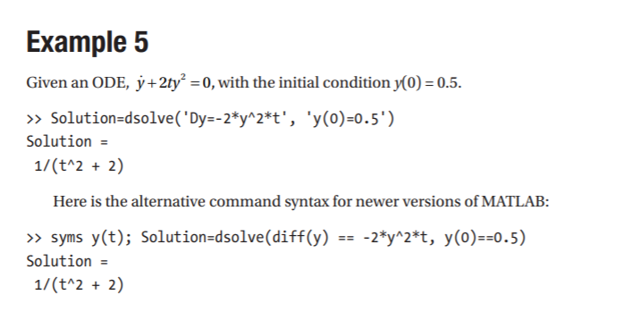

Y at the time to =0.5 ( y(t) = 0.5 at t0)

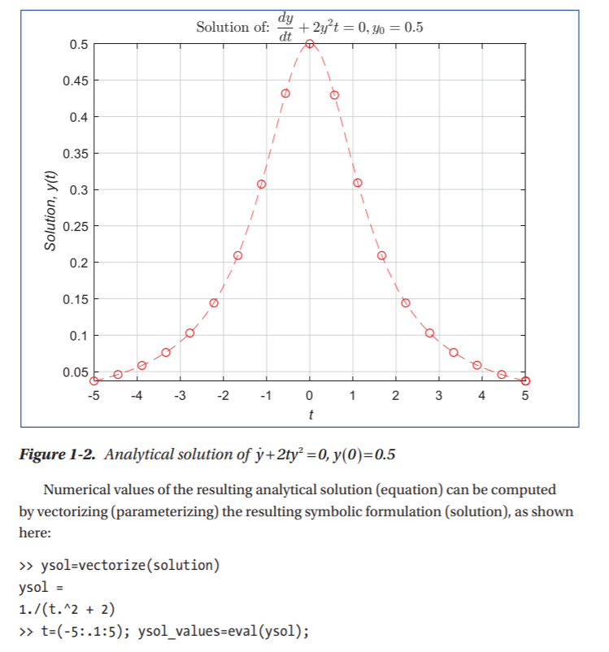

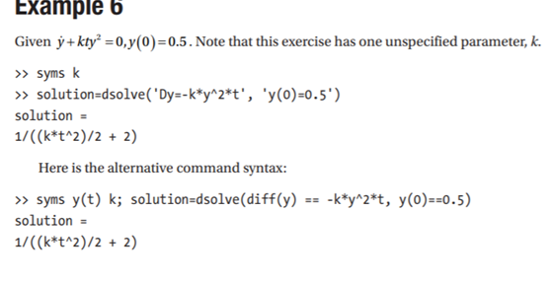

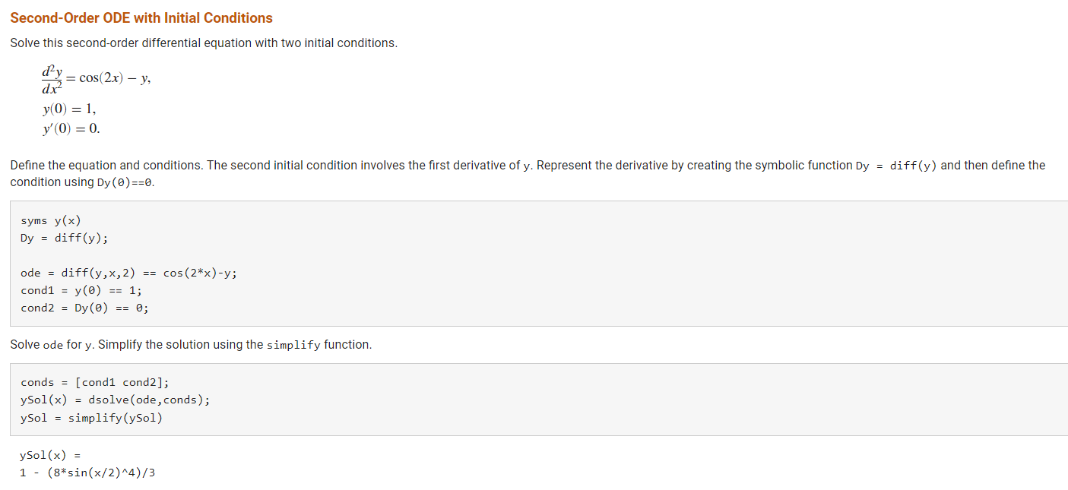

Ode45 and od23

[[t,y] = ode45(odefun,tspan,y0)](https://in.mathworks.com/help/matlab/ref/ode45.html#d123e975382)

[[t,y] = ode45(odefun,tspan,y0,options)](https://in.mathworks.com/help/matlab/ref/ode45.html#d123e975456)

[[t,y,te,ye,ie] = ode45(odefun,tspan,y0,options)](https://in.mathworks.com/help/matlab/ref/ode45.html#d123e975491)

[sol = ode45(**\_\_\_**)](https://in.mathworks.com/help/matlab/ref/ode45.html#d123e975557)

## Description

## 

[[t](https://in.mathworks.com/help/matlab/ref/ode45.html" \l "bu00_4l_sep_shared-t),[y](https://in.mathworks.com/help/matlab/ref/ode45.html#bu00_4l_sep_shared-y)] = ode45([odefun](https://in.mathworks.com/help/matlab/ref/ode45.html" \l "bu00_4l_sep_shared-odefun),[tspan](https://in.mathworks.com/help/matlab/ref/ode45.html#bu00_4l_sep_shared-tspan),[y0](https://in.mathworks.com/help/matlab/ref/ode45.html#bu00_4l_sep_shared-y0)), where tspan = [t0 tf], integrates the system of differential equations *y*′=*f*(*t*,*y*) from t0 to tf with initial conditions y0.

Each row in the solution array y corresponds to a value returned in column vector t.

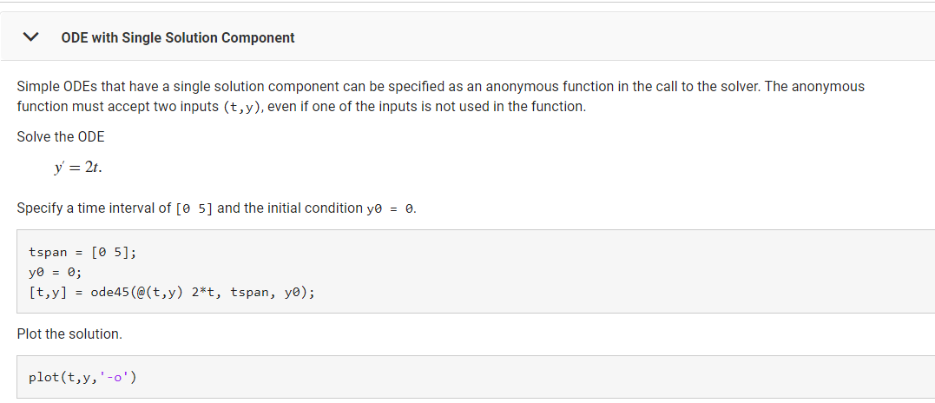

Tryout u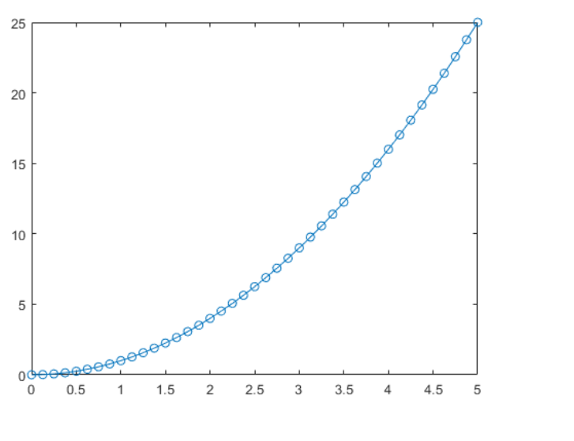

Tryout : replace od45 with od23